USER GUIDE FOR RETRIEVING WI-FI ACCESS CODE
This user guide provides the steps to retrieve free Wi-Fi access-code.
- Go to the link https://wifi.airmauritius.com
Enter your Ticket Number, Flight number and Flight Date and click on ‘Retrieve Code’ button.
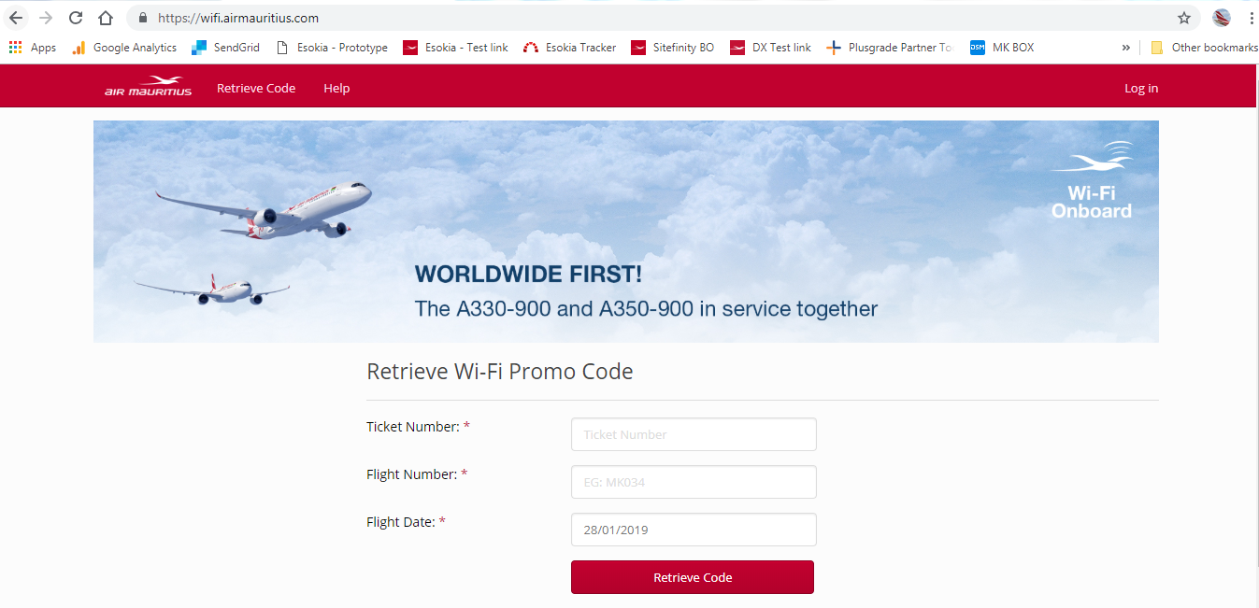

- Your code will be displayed on the screen; example shown below.
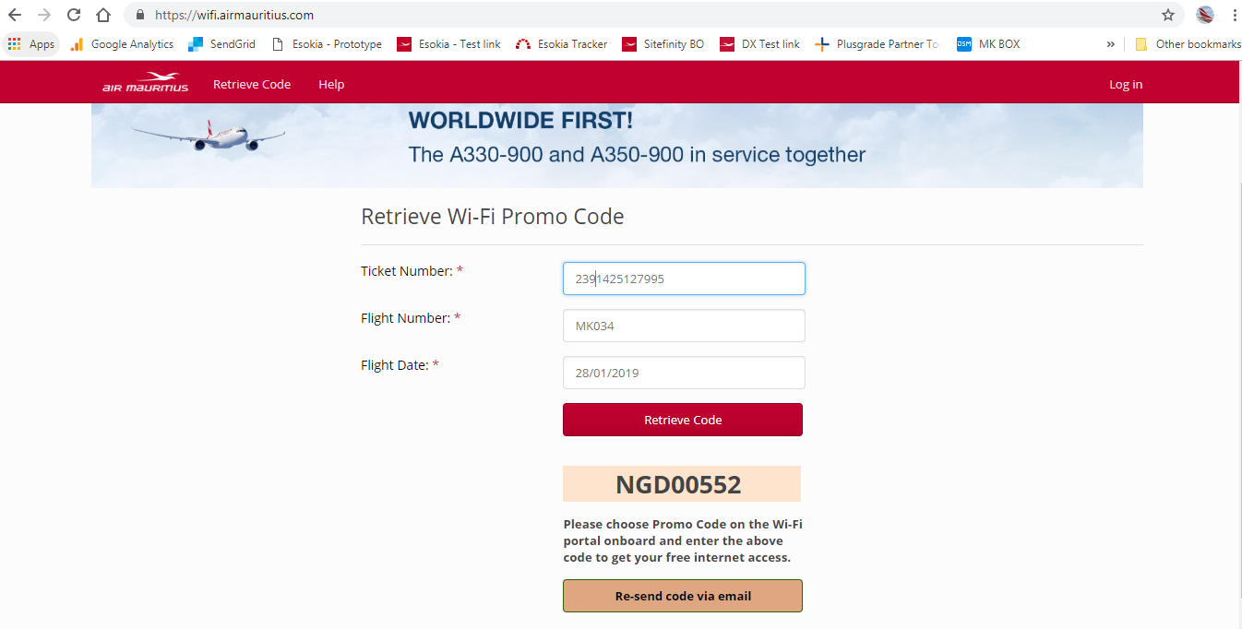
Onboard your flight, on the Wi-Fi portal, choose option ‘Promo Code’ and enter this 8-letter code to get free access to the internet.
PAUSE/RECONNECT FUNCTION
This function allows you to
- Pause and re-connect to an existing internet session.
- Purchase and use multiple Internet sessions on different devices at the same time
- Purchase an Internet session, which is valid on multiple flights – This is useful for flights with multiple segments, e.g. MRU-SIN-KUL, KUL-SIN-MRU, …

- Choose a Price Plan and click on Connect button. 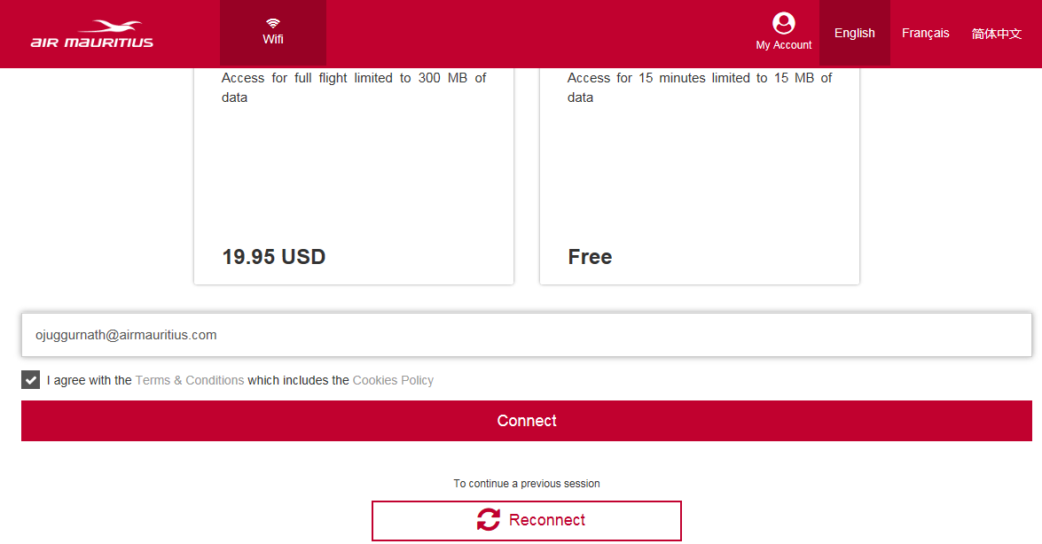

- You will be directed to a page where you will be prompted to create an account.
Creating an Account allows you to:
- Use your Internet Sessions on multiple devices
- Save your Credit Card details
- Access your purchase history
Click on Create an Account button.
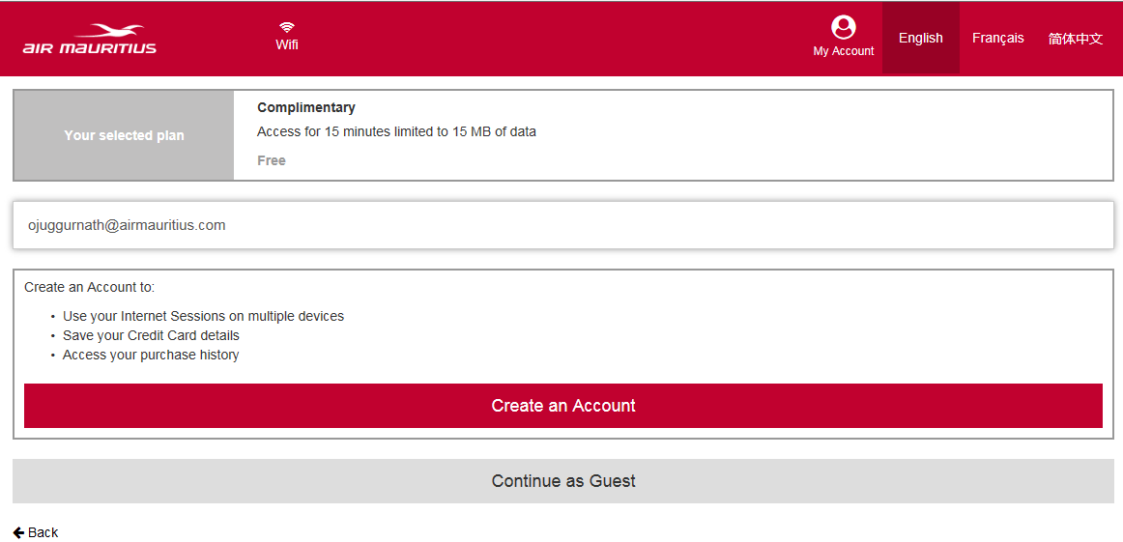
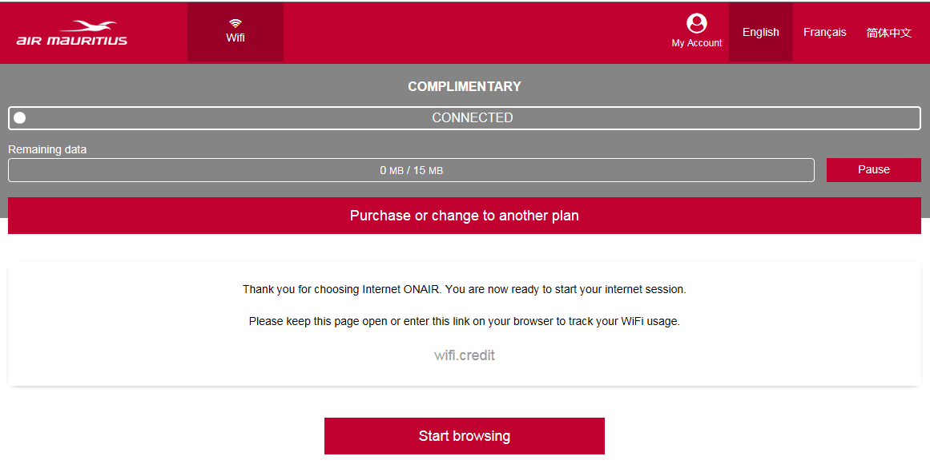
- Click on Start browsing button.
The progress bar highlighted in yellow above will show the time and volume of data remaining.
To pause a session, click on Pause.
To re-connect to a session, click on Reconnect.

